**B.M.S. COLLEGE OF ENGINEERING BENGALURU**

Autonomous Institute, Affiliated to VTU



Lab Record

**Software Engineering and Object-Oriented Modeling**

*Submitted in partial fulfillment for the 6th Semester Laboratory*

Bachelor of Engineering

in

Computer Science and Engineering

*Submitted by:*

**Jyothika C N**

1BM21CS083

Department of Computer Science and Engineering

B.M.S. College of Engineering

Bull Temple Road, Basavanagudi, Bangalore 560 019

Mar-June 2024

**B.M.S. COLLEGE OF ENGINEERING**

**DEPARTMENT OF COMPUTER SCIENCE AND ENGINEERING**



***CERTIFICATE***

This is to certify that the Object-Oriented Analysis and Design(22CS6PCSEO) laboratory has been carried out by Jyothika C N (1BM21CS083) during the 6th Semester Mar-June-2024.

Signature of the Faculty Incharge:

Dr. Pallavi G B

Department of Computer Science and Engineering

B.M.S. College of Engineering, Bangalore

|  |  |
| --- | --- |
| 1 | Hotel Management System |
| 2 | Credit Card Processing |
| 3 | Library Management System |
| 4 | Stock Maintenance System |
| 5 | Passport Automation System |

Table of Contents

1. Hotel Management System

* 1. Problem Statement and SRS

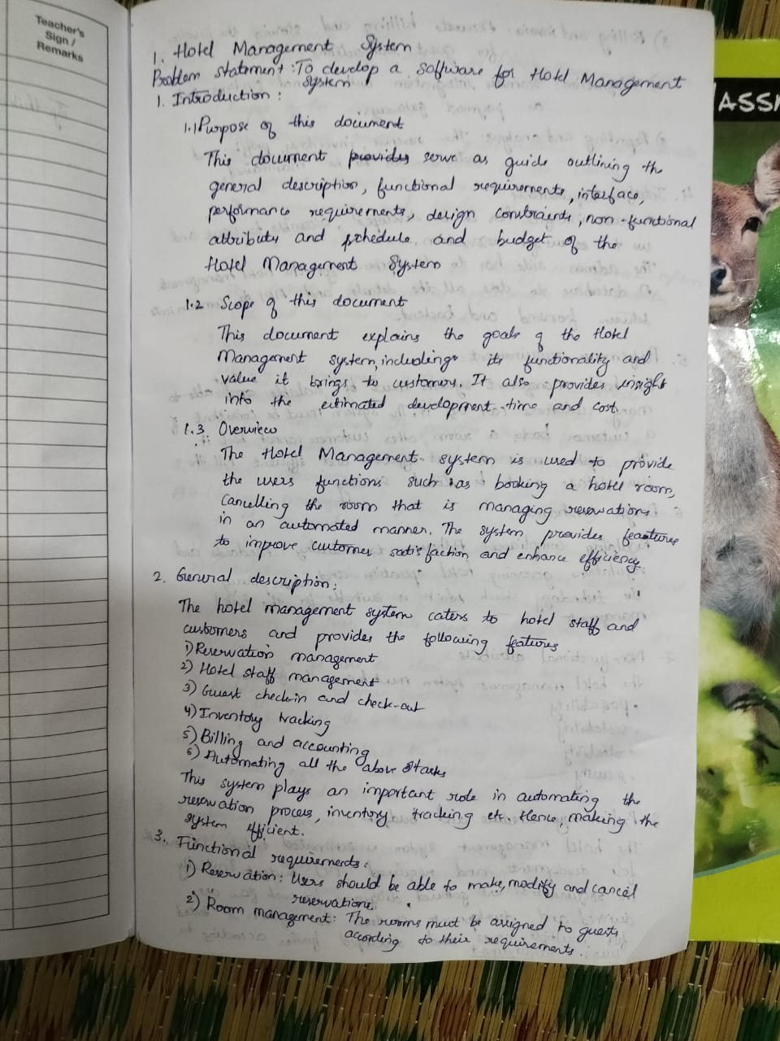

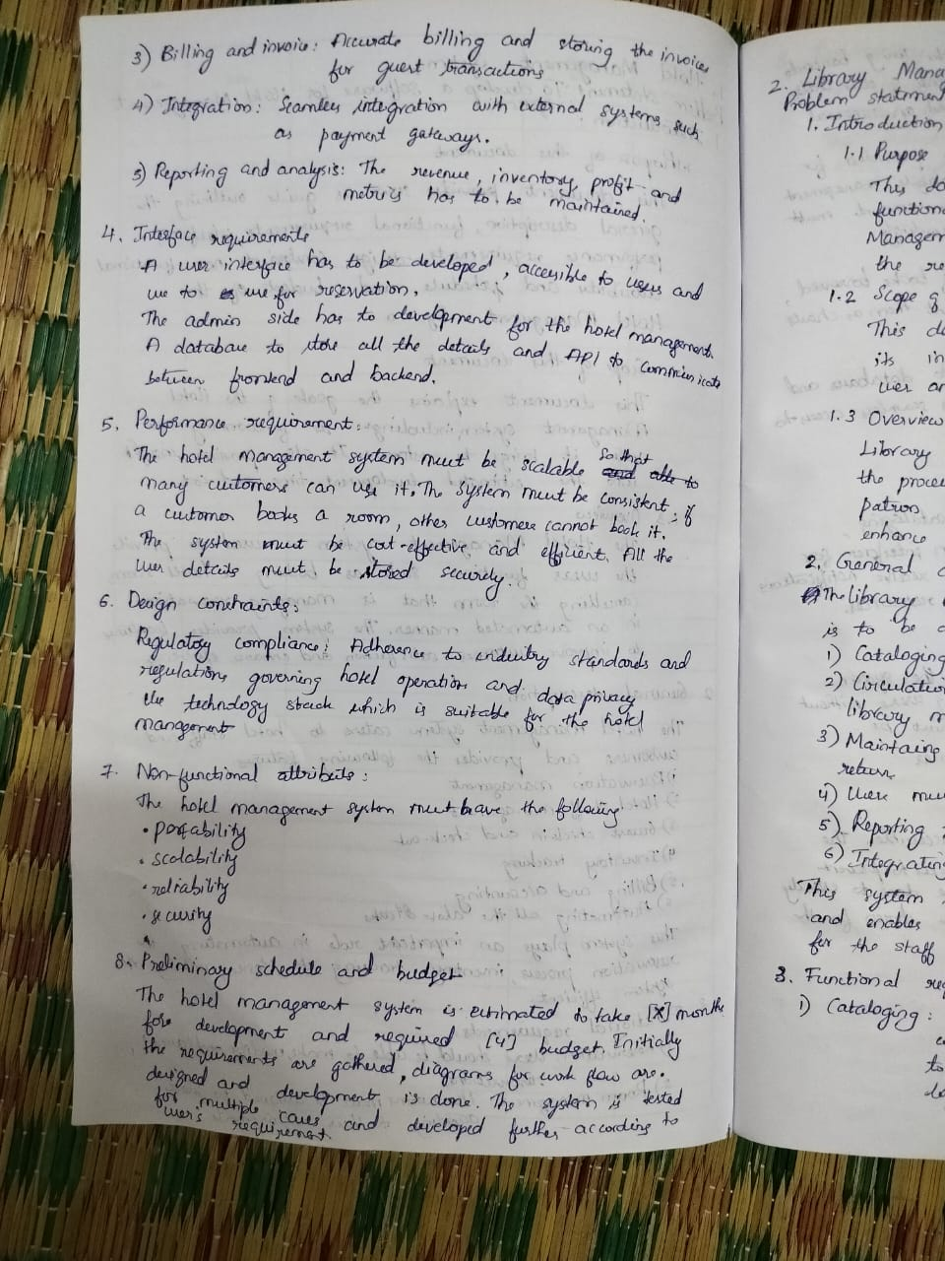

* 1. Class Diagram

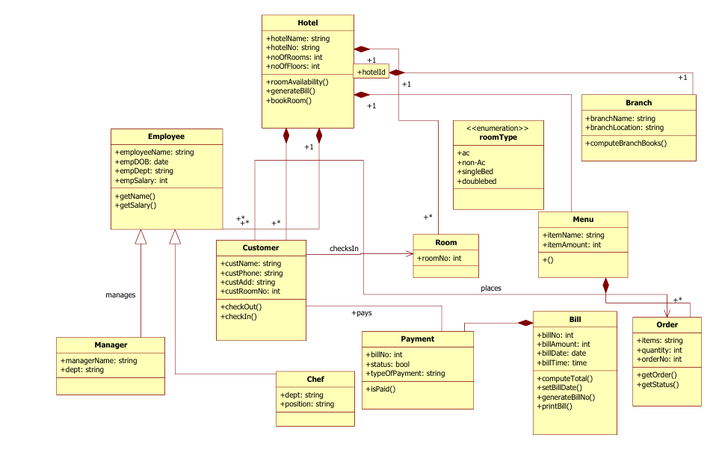

* 1. State Diagram

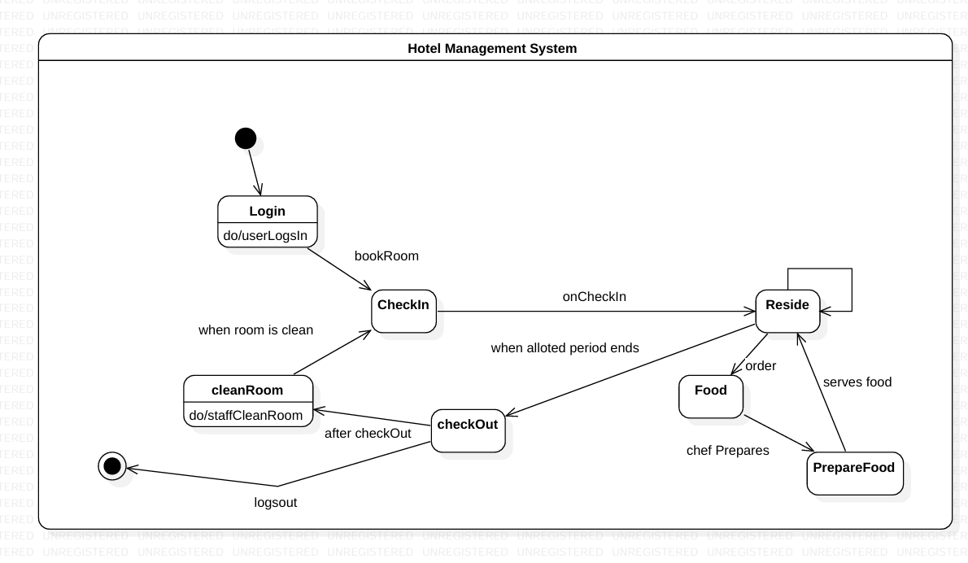

* 1. Use Case Diagram

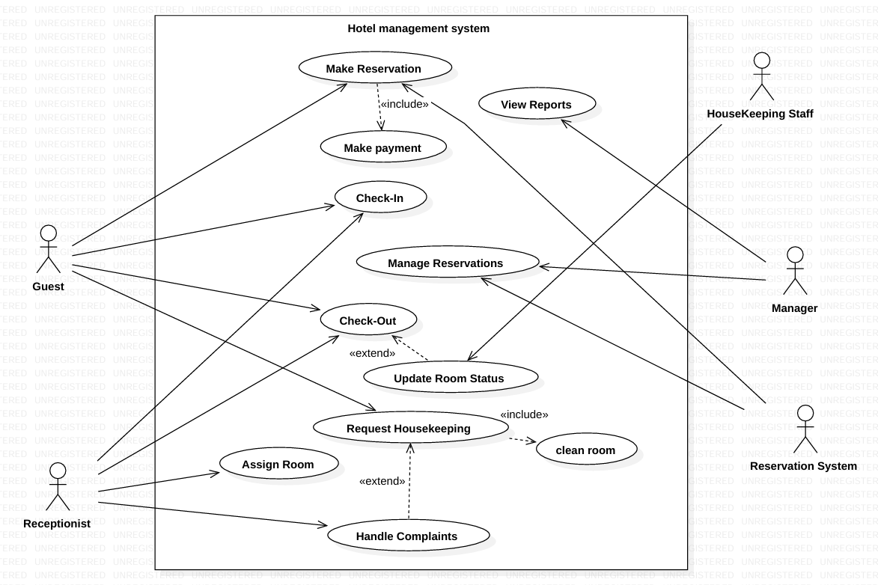

* 1. Sequence Diagram

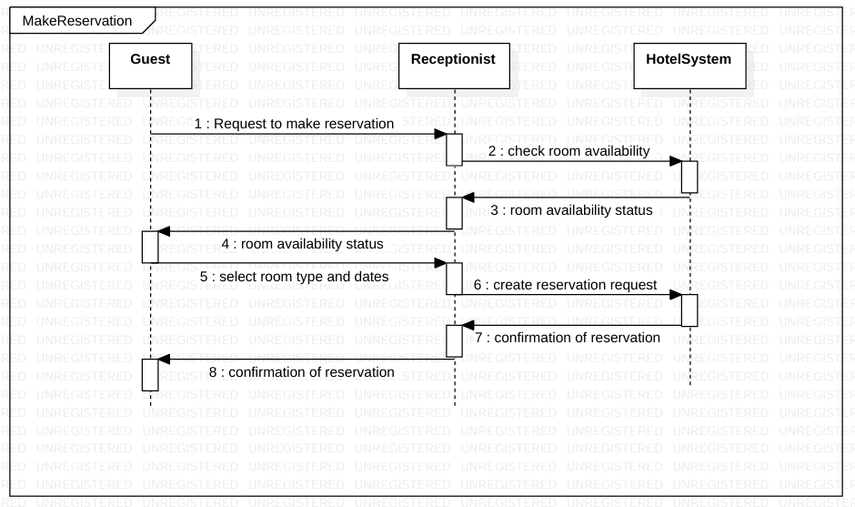

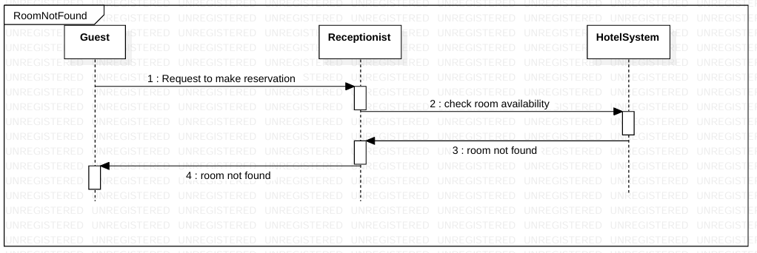

* 1. Activity diagram

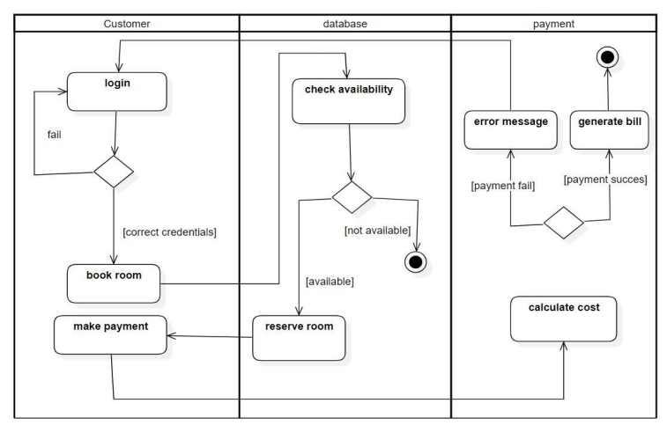

2. Credit Card Processing System

* 1. Problem Statement and SRS-Software Requirements Specification

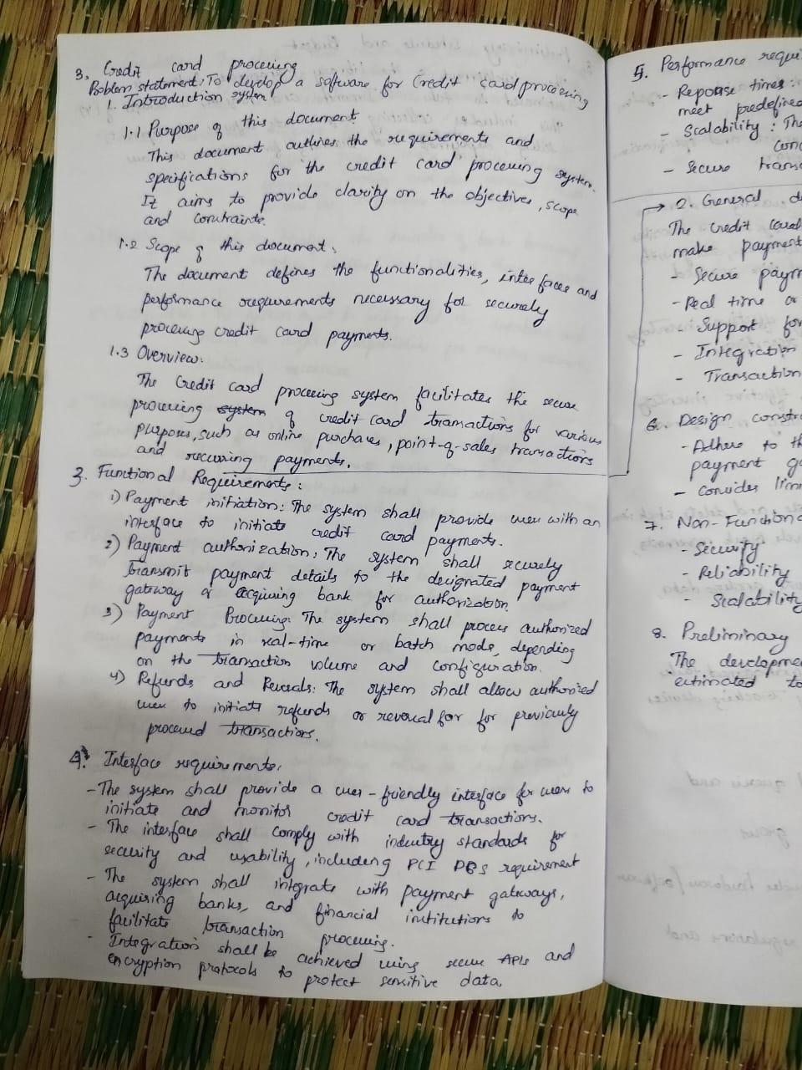

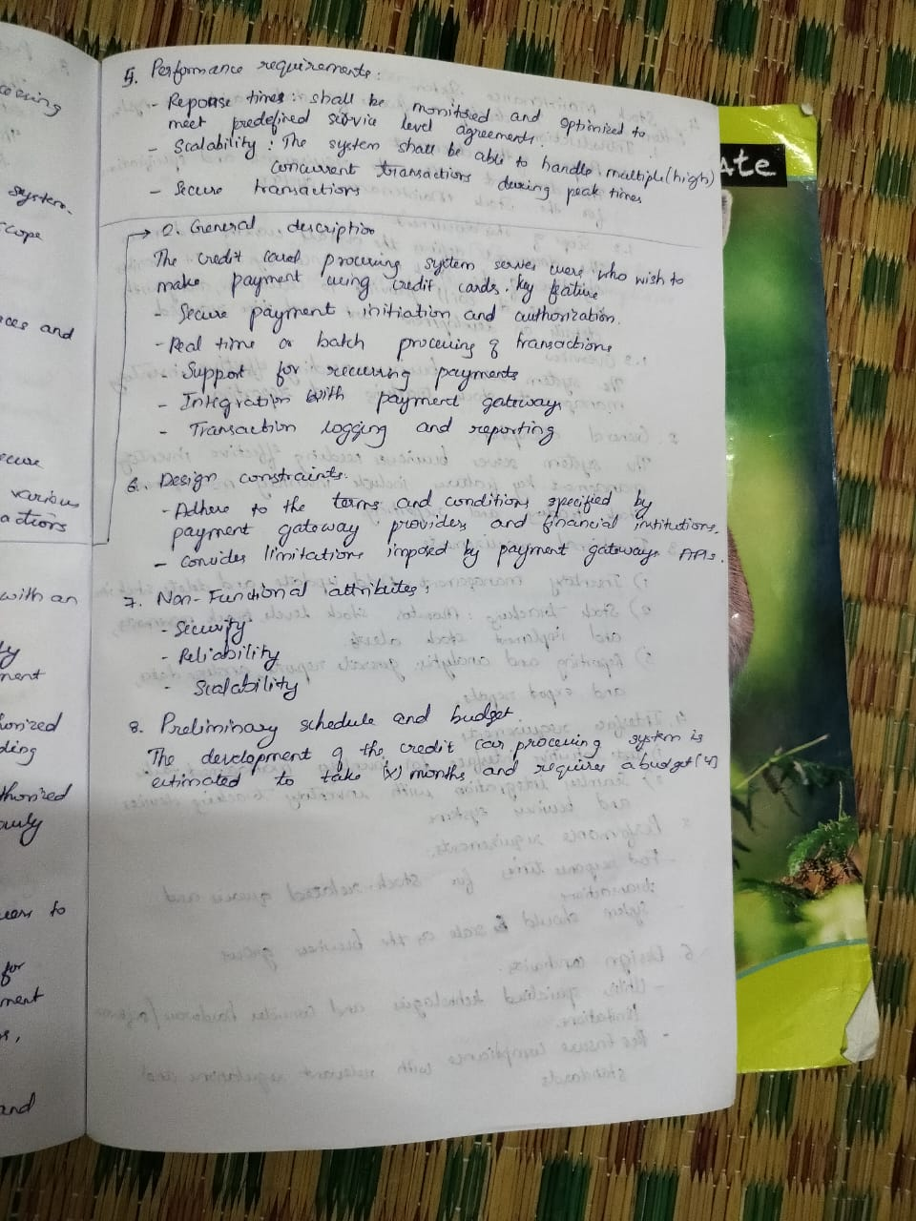

* 1. Class Diagram

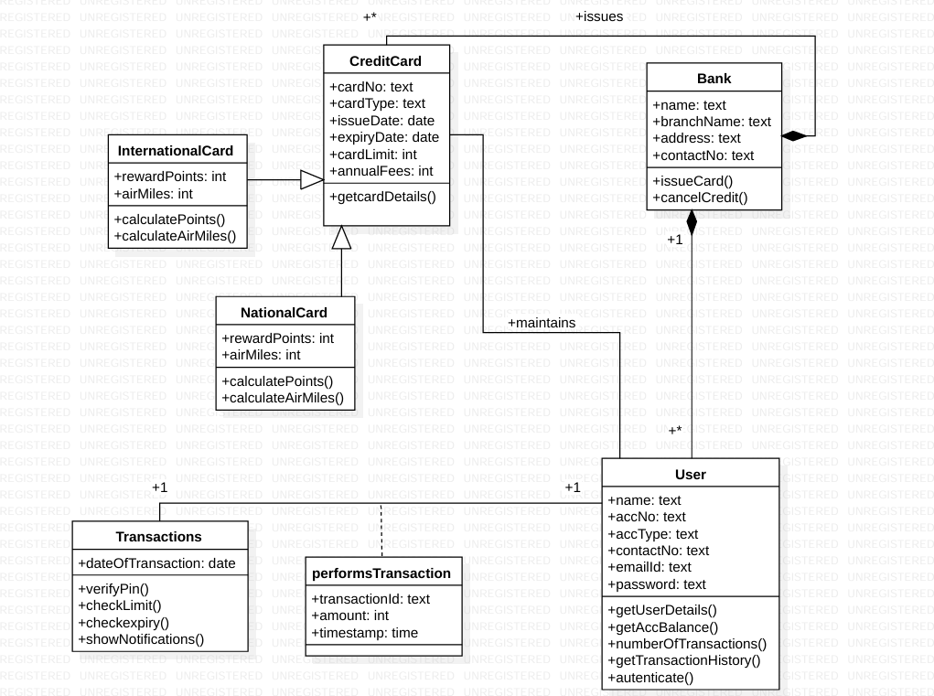

* 1. State Diagram

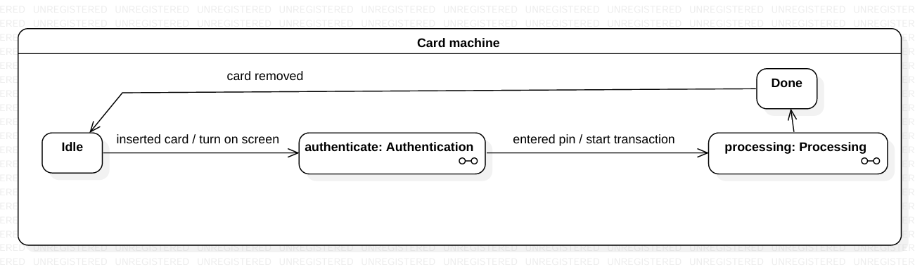

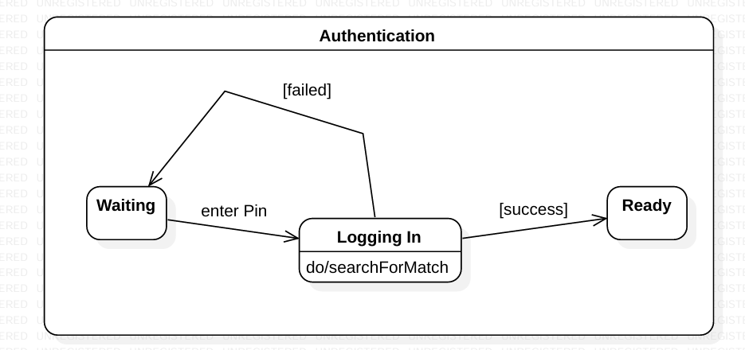

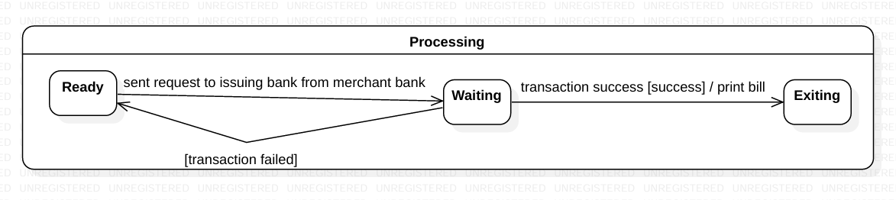

* 1. Use Case Diagram

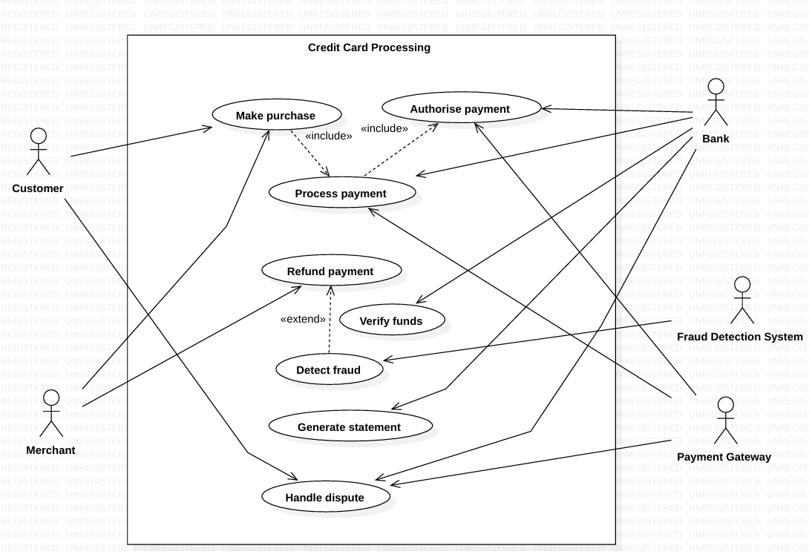

* 1. Sequence Diagram

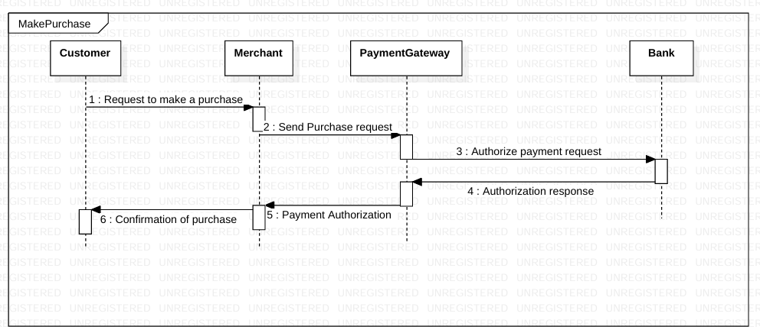

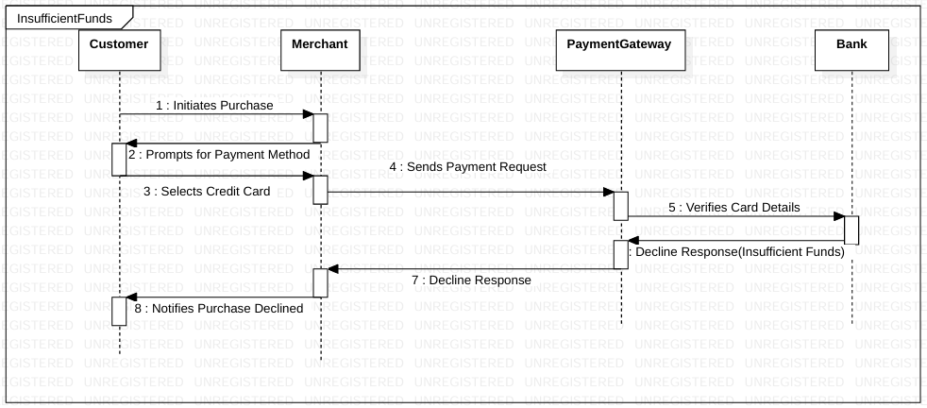

* 1. Activity diagram

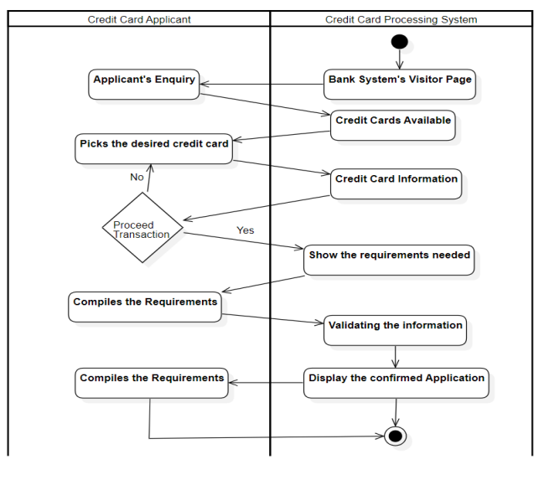

3. Library Management System

* 1. Problem Statement and SRS-Software Requirements Specification

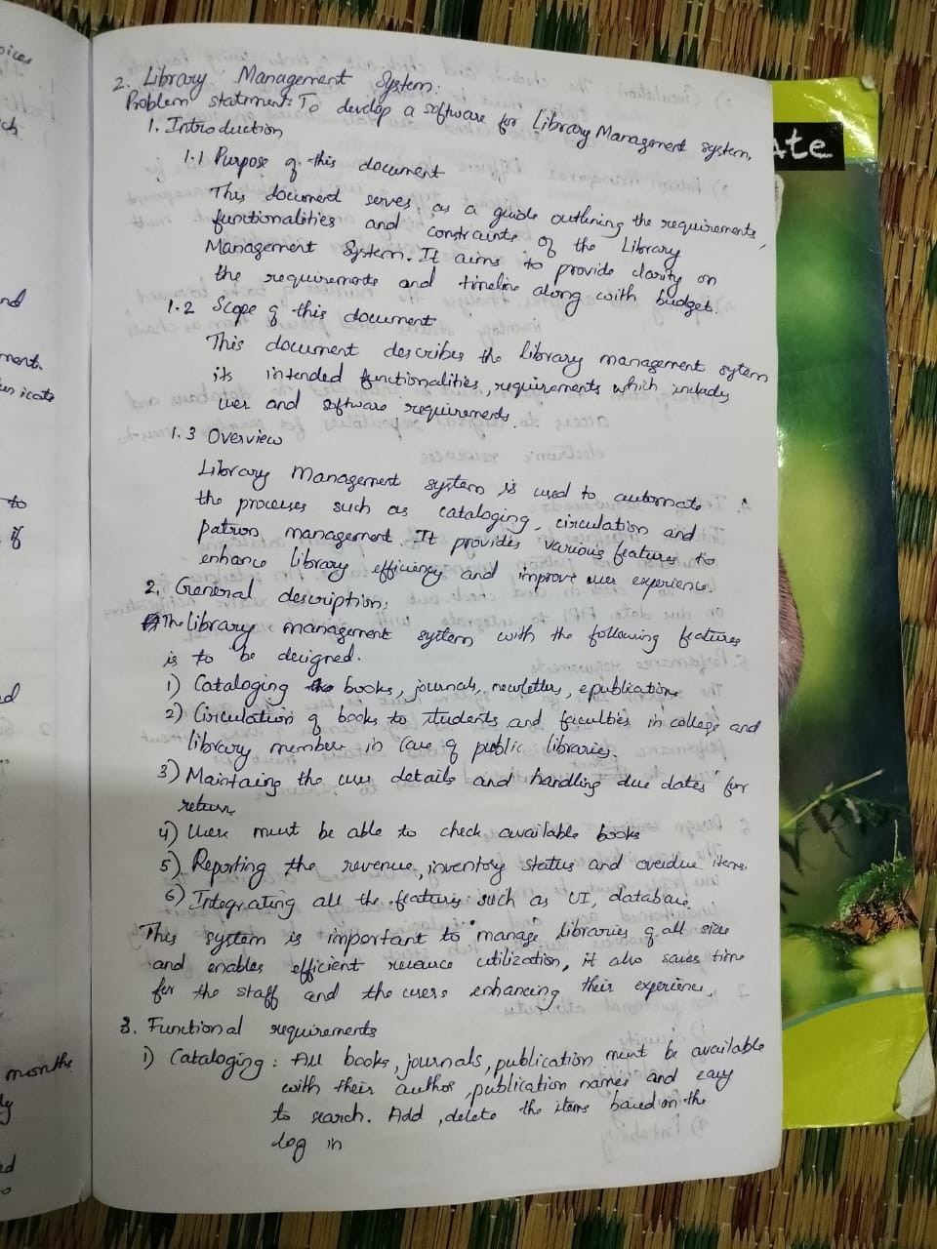

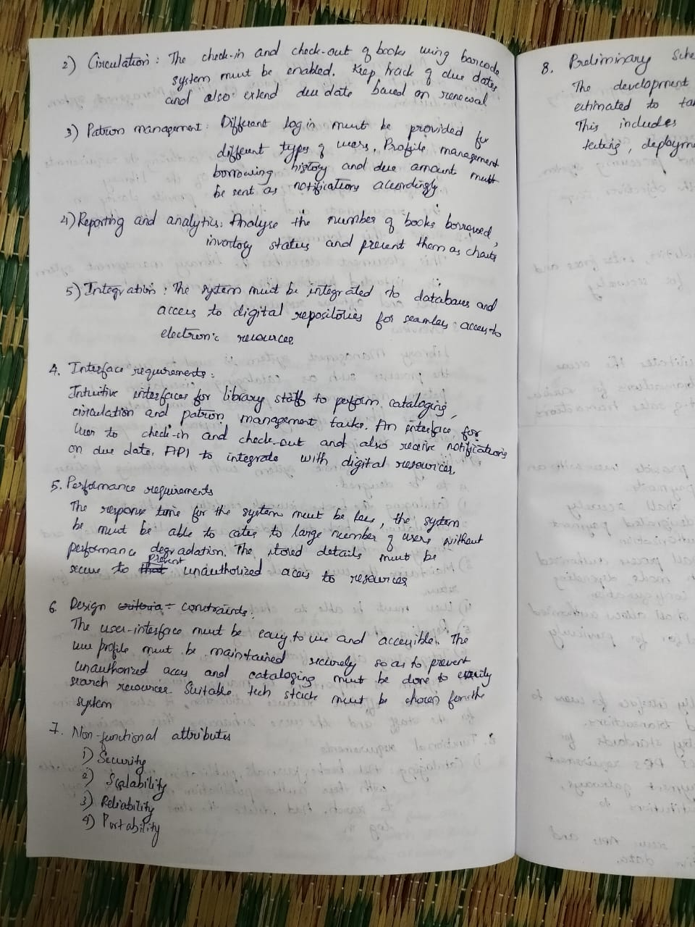

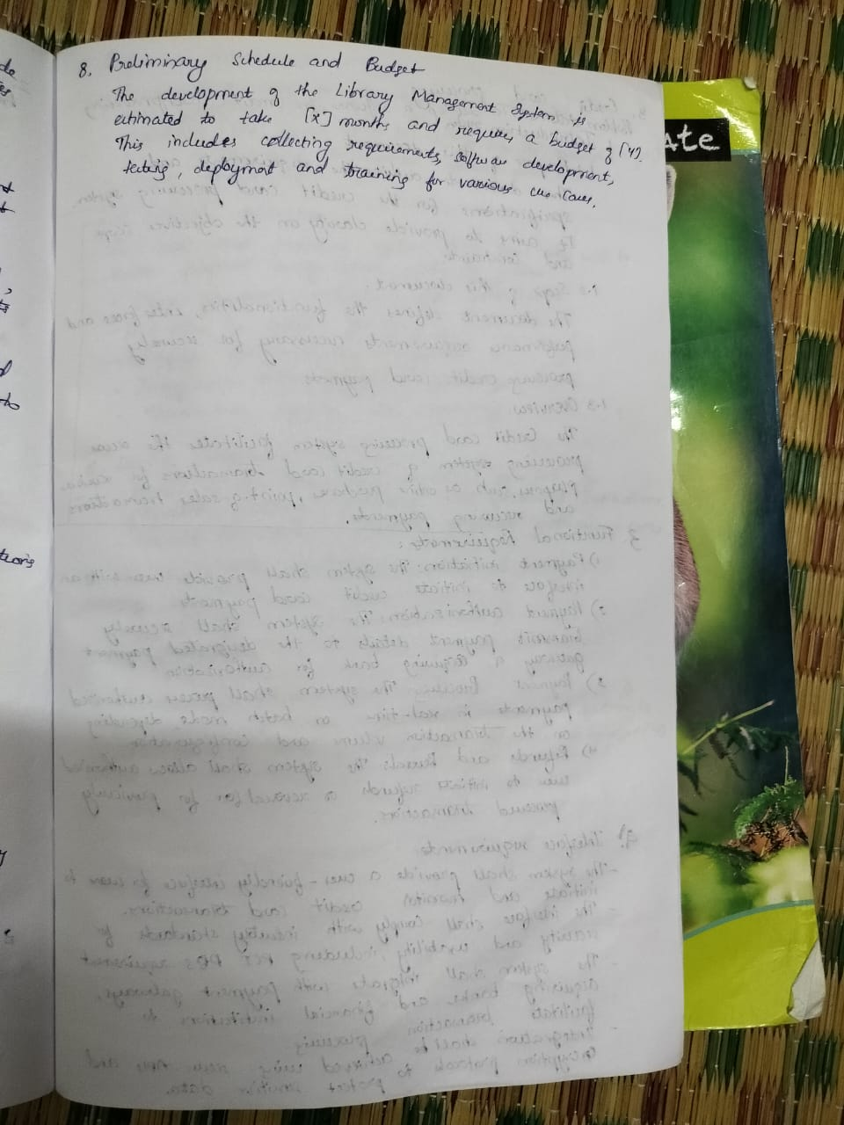

* 1. Class Diagram

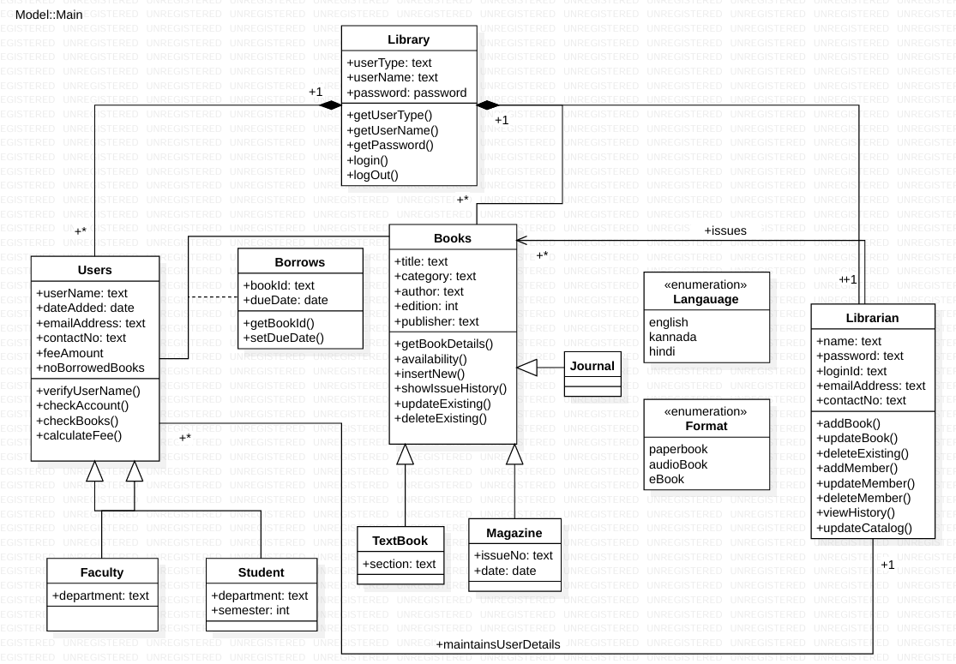

* 1. State Diagram

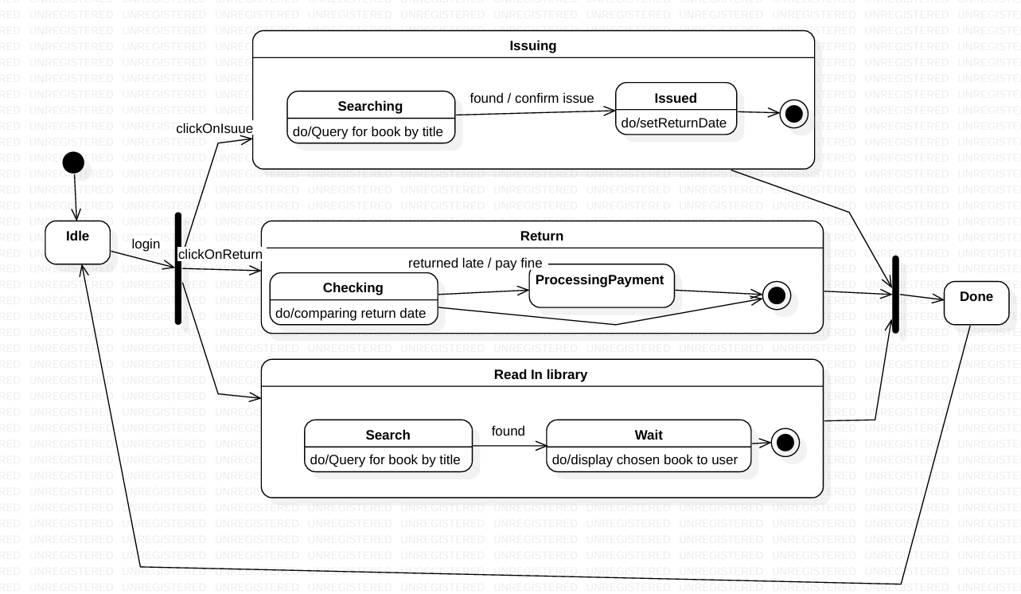

* 1. Use Case Diagram

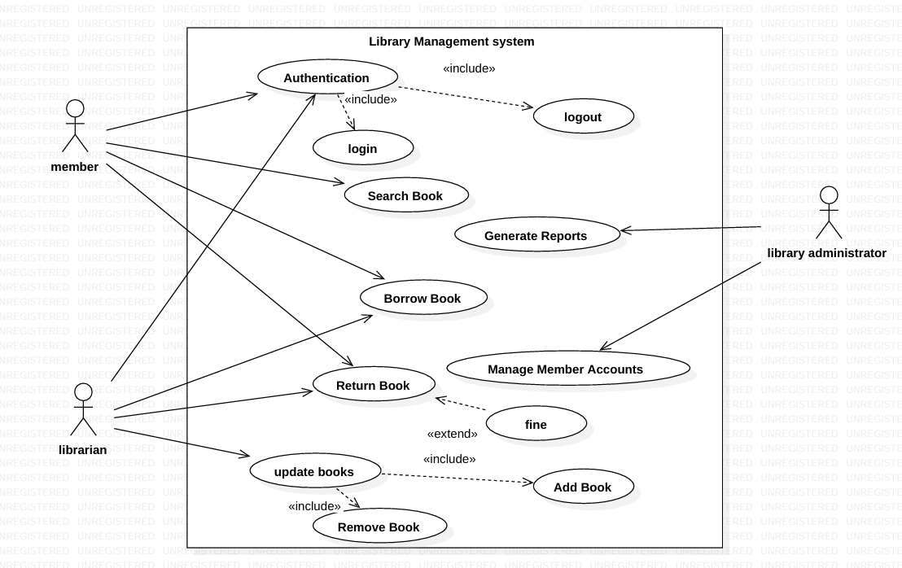

* 1. Sequence Diagram

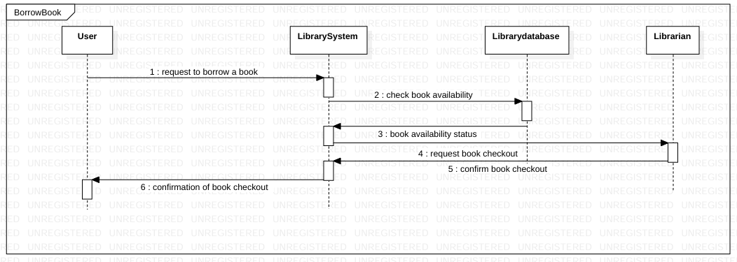

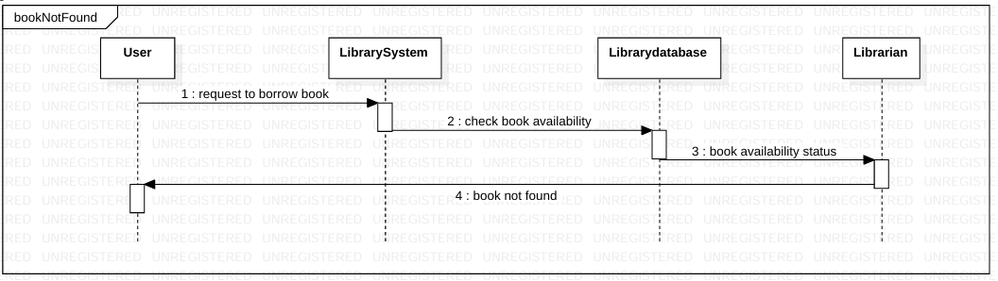

* 1. Activity diagram

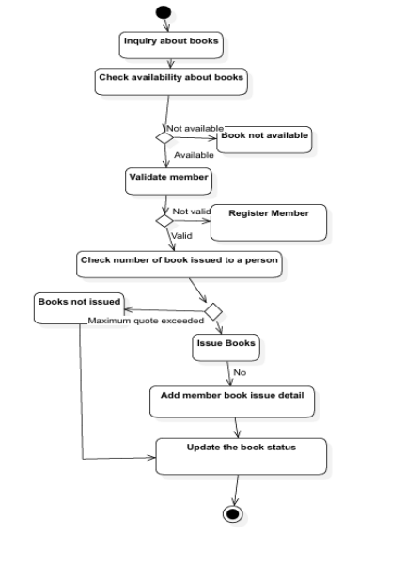

4. Stock Maintenance System

* 1. Problem Statement and SRS-Software Requirements Specification

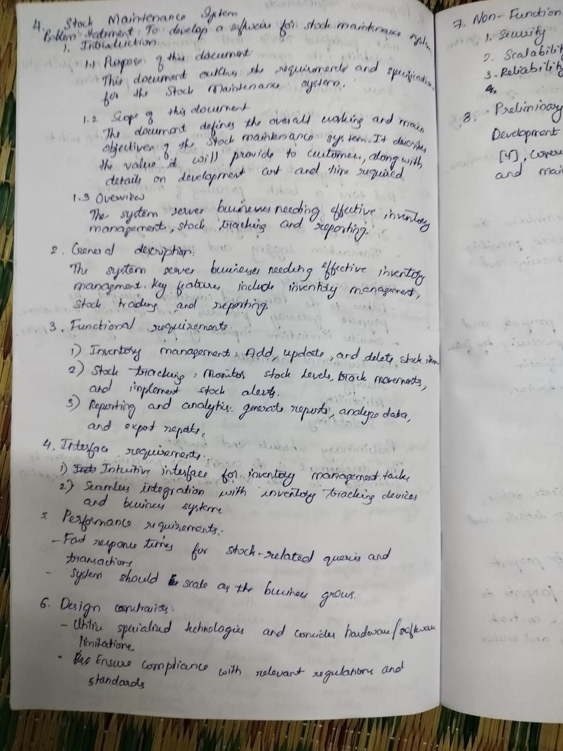

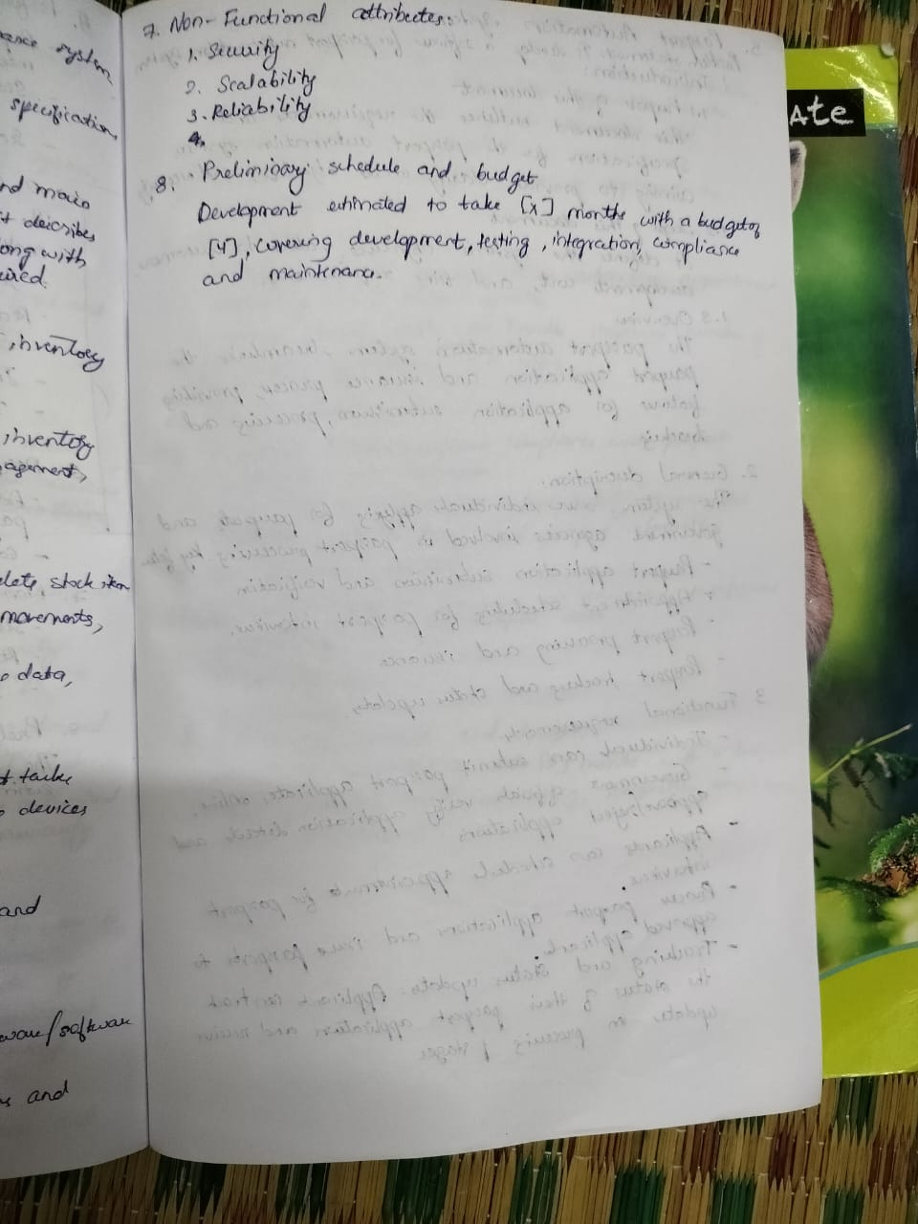

* 1. Class Diagram

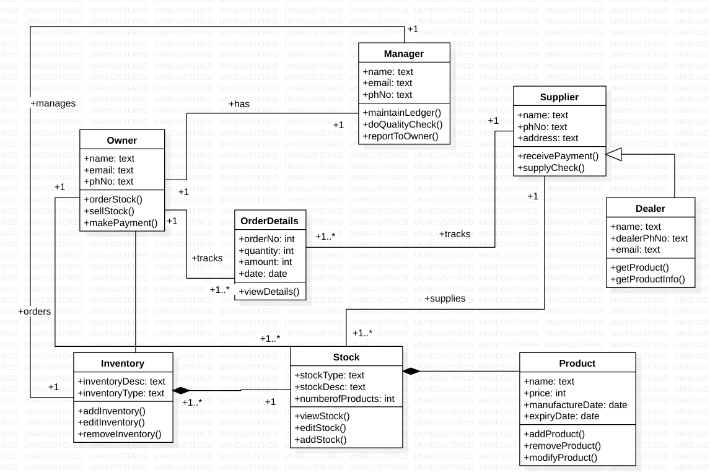

* 1. State Diagram

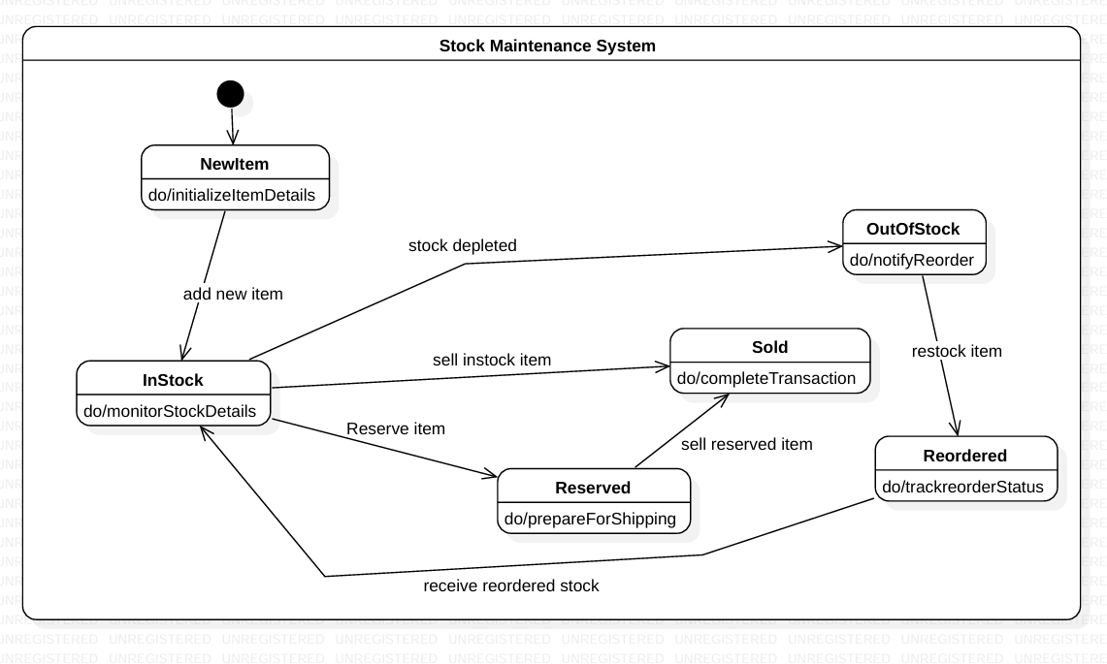

* 1. Use Case Diagram

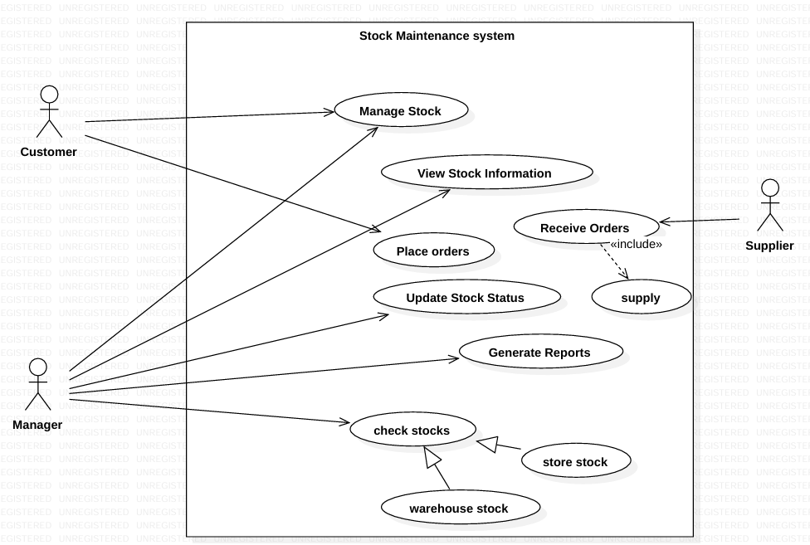

* 1. Sequence Diagram

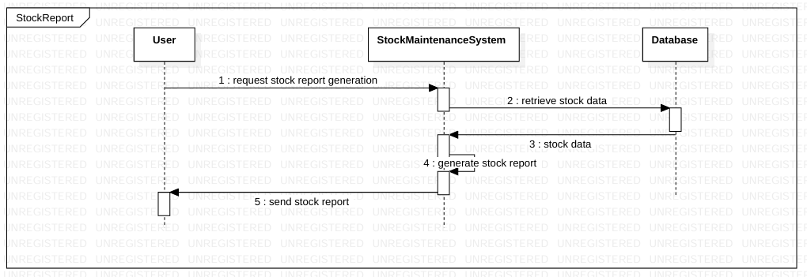

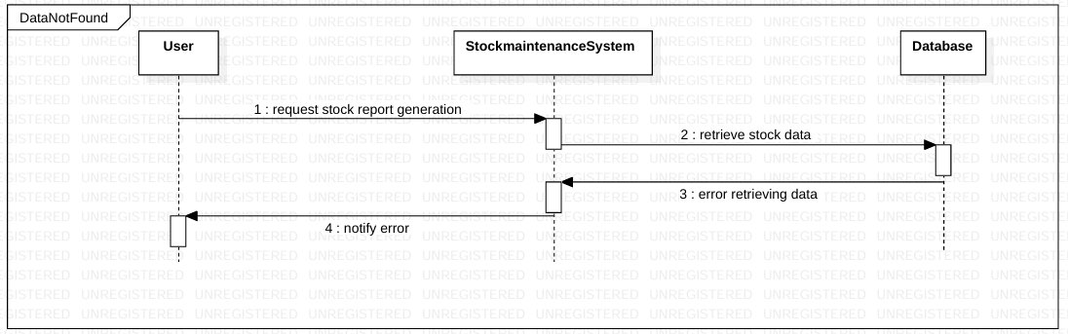

4.7 Activity diagram

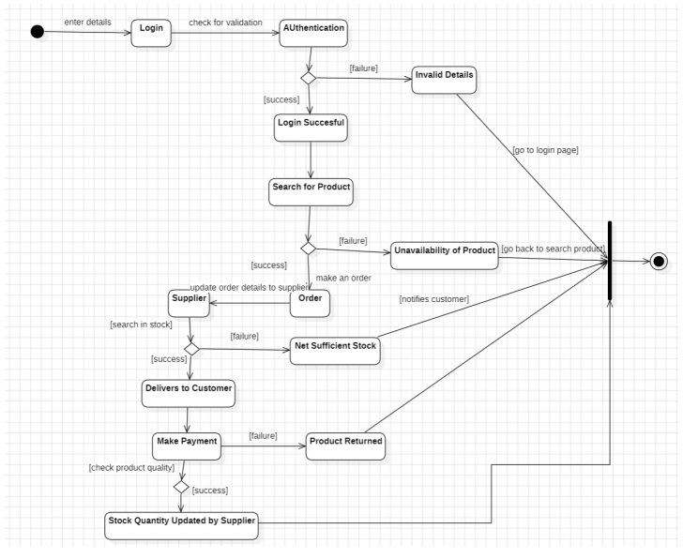

5. Passport Automation System

* 1. Problem Statement and SRS-Software Requirements Specification

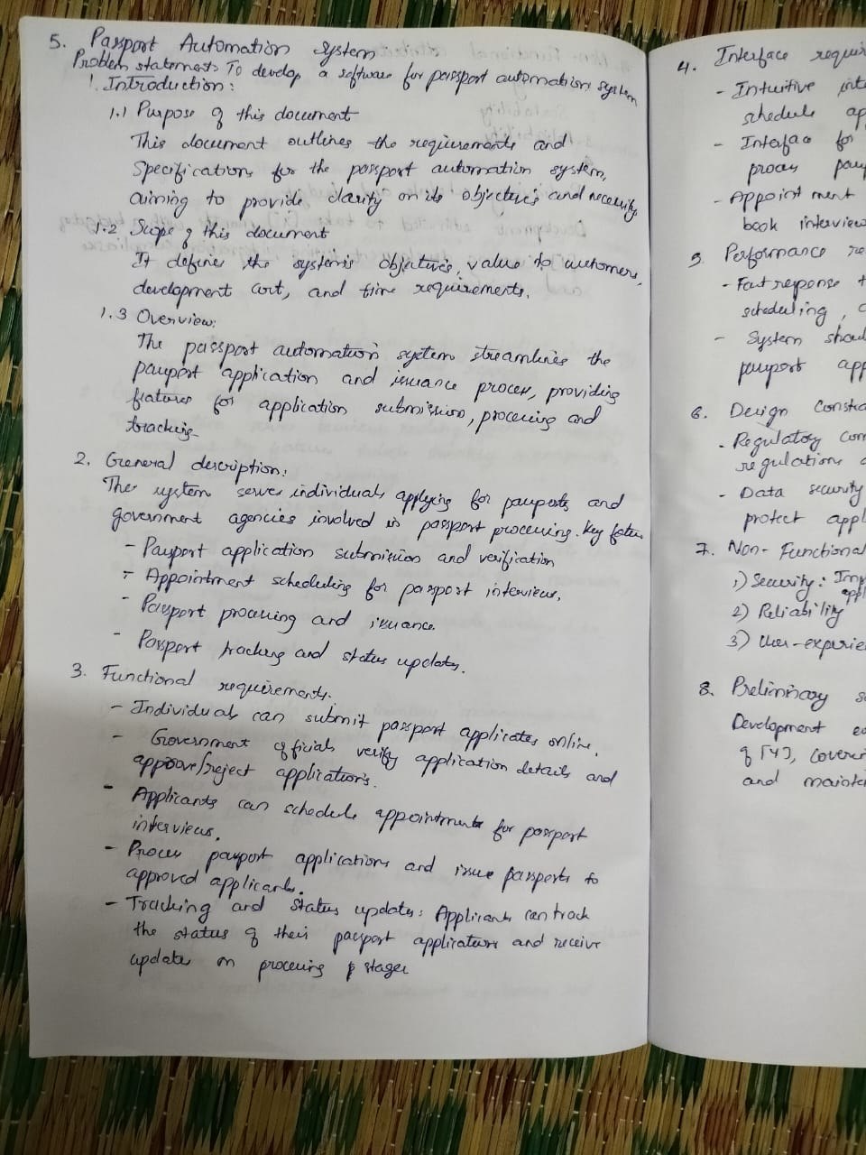

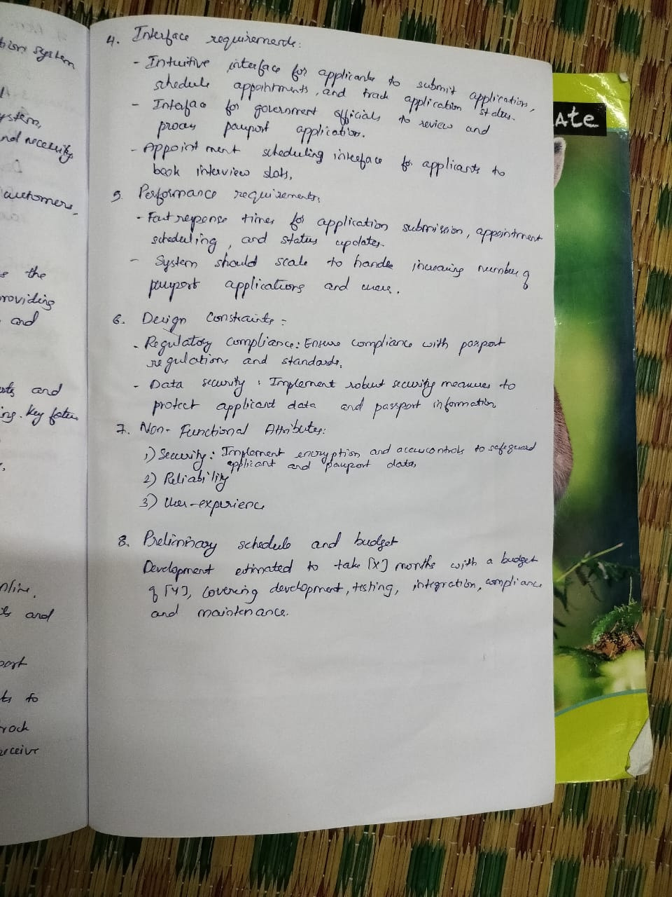

* 1. Class Diagram

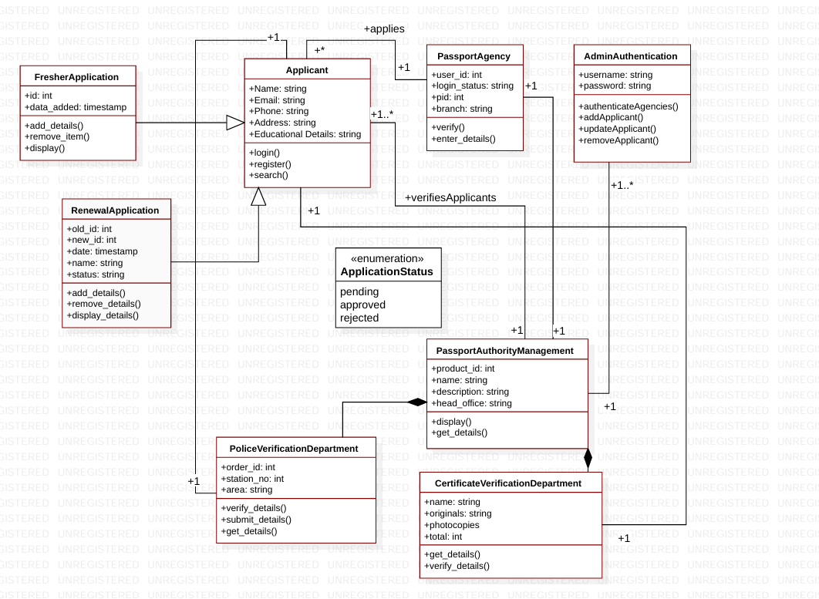

* 1. State Diagram

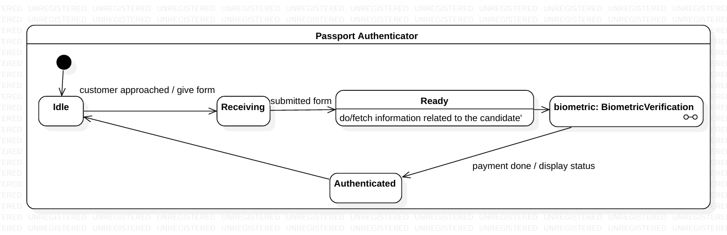

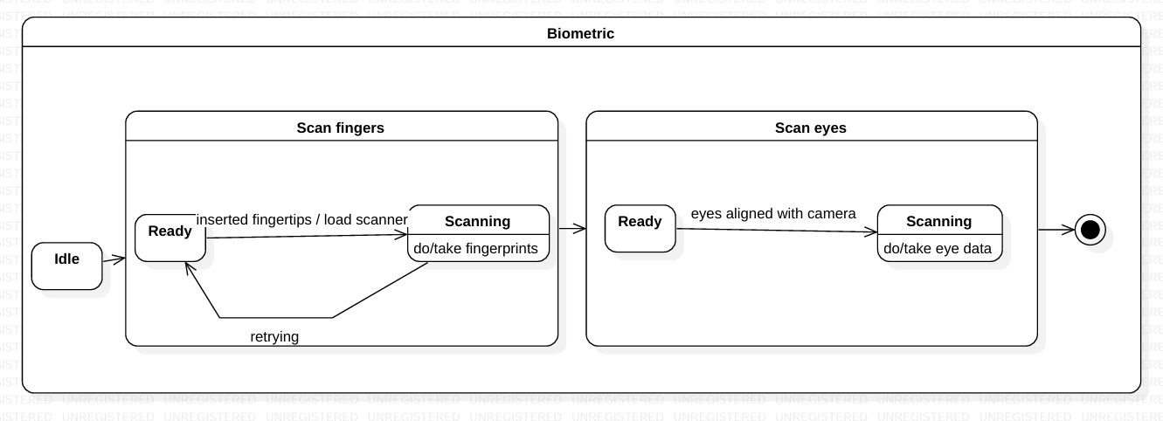

* 1. Use Case Diagram

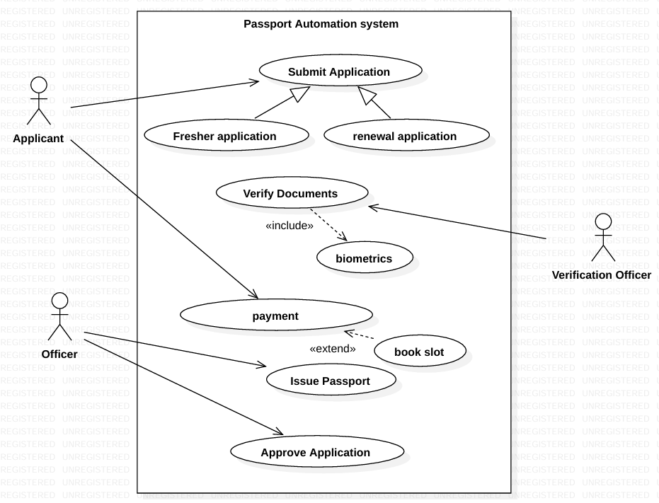

* 1. Sequence Diagram

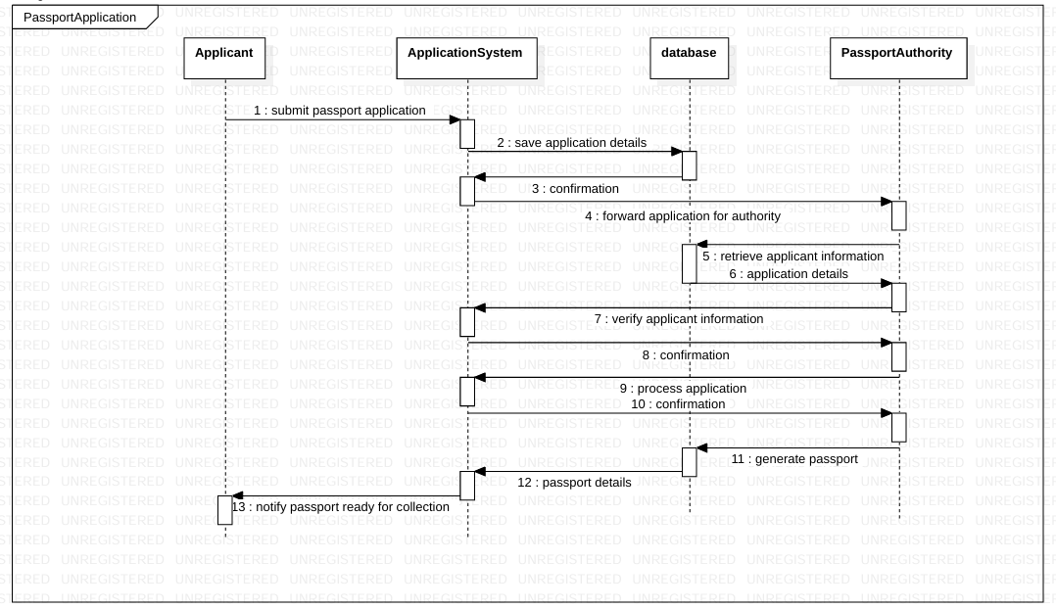

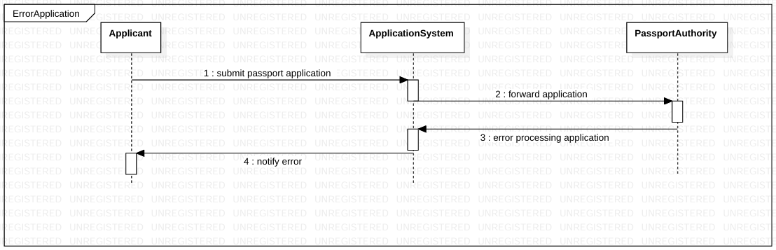

5.7 Activity diagram

